Yearbook
April 13 - 17
What you will need:
Computer/device
Internet
School e-mail/TEAMS/Yearbook Avenue

What you will do:

M 4/13 | T 4/14 | W 4/15 | Th 4/16 | F 4/17
Submit a photo of your Inspiration Page to Assignments (if you did not do this last week)  Add a photo of YOURSELF to our Teams classroom  Work on Yearbook page (20-30 minutes) | Work on Yearbook page (20-30 minutes) | Work on Yearbook page (20-30 minutes)  Post to Discussion Board in TEAMS (read instructions below) | Work on Yearbook page (20-30 minutes) | Work on Yearbook page (20-30 minutes)  Turn-in Weekly Progress
Use the boxes below to CHECK when above task is completed (optional):

What you will learn:
Begin/continue your assigned yearbook page.

How you will complete your work:
Add a Photo:
We miss you and it will be great to see your face! Add a NICE and school appropriate photo of yourself to our Teams classroom!

- Go to your Team classroom. In the upper right corner, click the circle for your profile. Click “Change picture”
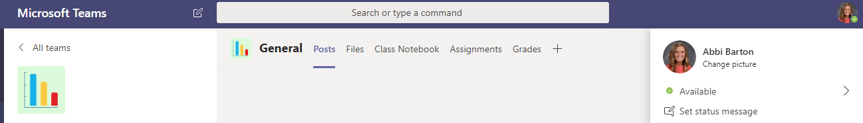

- In the next window, click “Upload picture.” Find the photo saved in your files.

Don’t have a photo? EMAIL ME! I will send you your yearbook photo

WORK ON YEARBOOK PAGE
- You should be working 20-30 minutes per day MINIMUM! That is a little over 2 hours per week; YearbookAvenue shows me when you signed in, what page you worked on, how long you worked, and what steps you completed.
- Keep in mind you are producing something REAL that people paid for. Please make Yearbook a priority.
- You will be graded on the quality of your work and your progress
- If you do not meet appropriate progress, you will be removed from the page.

Page assignments.
Chloe: Senior Photos
Daelyn: Homecoming
Erika: Senior Best
Abby B: Football
Katie: Volleyball
Jamilya: Boys Soccer
Madison: Golf
Jessie: Senior Life
Tristan: Sophomore Life
Tyler: Freshman Life

Make a Discussion Board POST in Teams
- One the left side of your Team, click DISCUSSION BOARD.
- POST: How is Yearbook design going? What is going well, what is a struggle? What tips, advice, or ideas can you give others? Talk as if we are in class checking up on each other. Tell us things that are working for you, ideas you are finding, what you need help on. At least a couple sentences.
- REPLY to at least ONE of your classmates –give helpful feedback, suggestions, relate to their feelings. Reply like you are in class and this person asked you for help, opinion, or feedback. At least a couple sentences.

TURN-IN WEEKLY PROGRESS
- In Teams, go to Assignments > open Weekly Production sheet for this week.
- Save by adding YOUR NAME to the save: Ex: Jane Smith Weekly Production
- REFLECT and respond to the statements under each category. Describe how your week went while working on the yearbook. Be honest with what was good, what didn’t go as planned, what you plan to do, your ideas for your page, how you have interacted, etc.
- At the bottom, you will give yourself a grade out of 20 points.
- Save and upload to Assignments by selecting “+Add Work” to attach.

